

**Assignment 1**

**Pencil colour study**

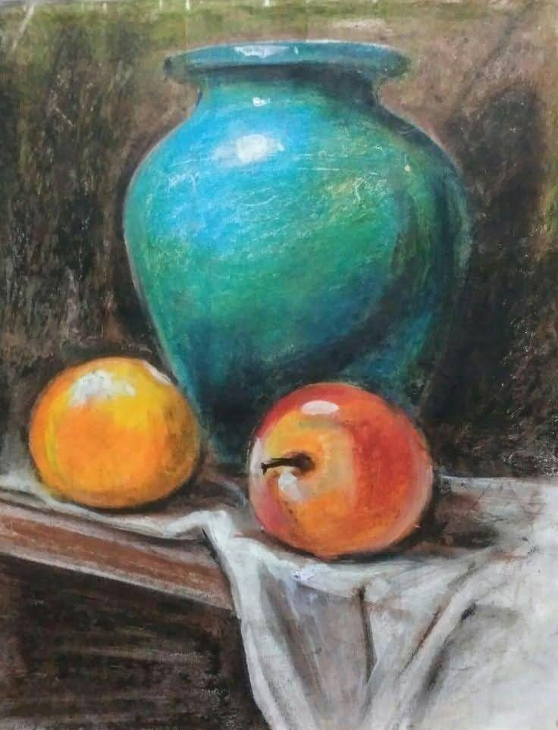

**Assignment 2**

**Pastel colour study**

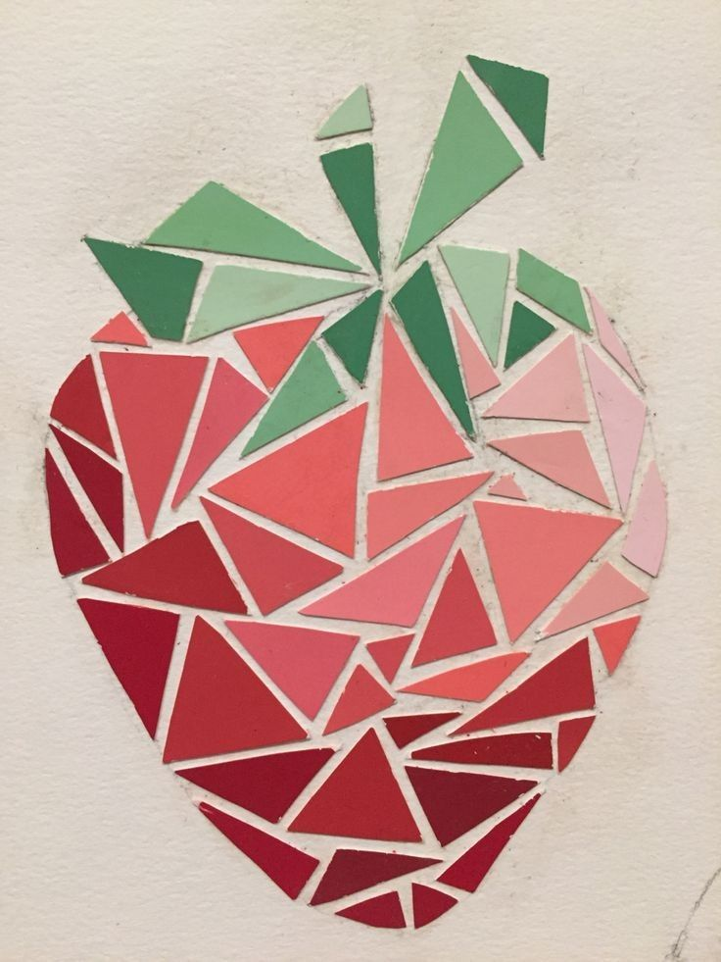

**Assignment 3**

**Mosaic Work**

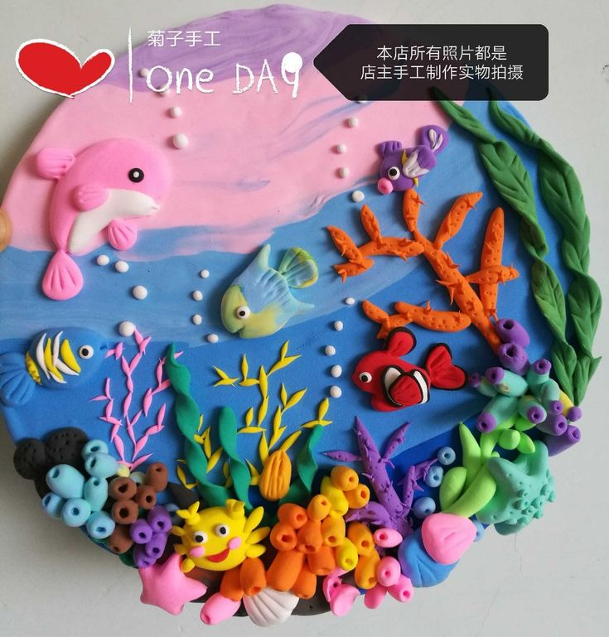

**Assignment 4**

**Play dough work**

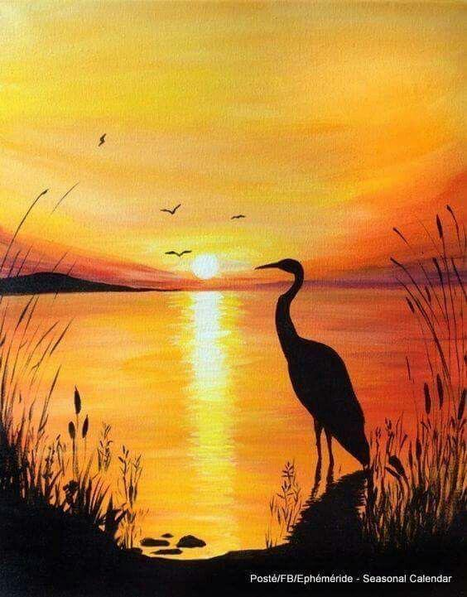

**Assignment 5**

**Landscape**